* Contains peanuts and lactose

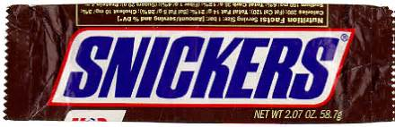

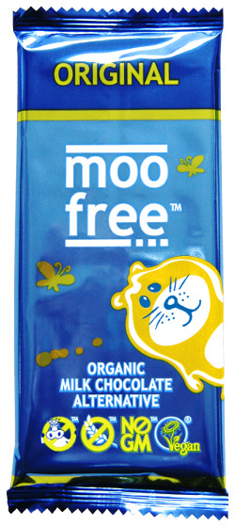

* + - Allergen free
* Contains peanuts, lactose, and gluten

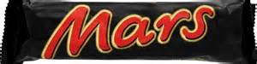

* 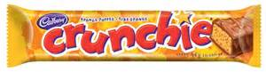Contains lactose